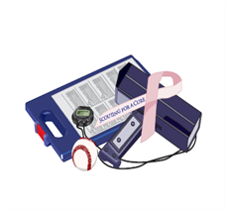

Wednesday- October 8, 2014

Indian Springs Country Club

115 Elmwood Road

Marlton, NJ

Registration: 10:00 am

11:30 am ~Shotgun Start~Box Lunch

5:00 pm Cash bar-‘BBQ' Menu

Raffles ~ Silent Auction

Baseball Memorabilia!

Participation Opportunities

Dinner Sponsor $750,

•  Foursome ( Lunch, Extras & Dinner)

• Signage prominently displayed at Clubhouse

Course Refreshments Sponsor $350.

• Twosome (Box Lunch, Extras & Dinner)

Closest to the Pin Sponsor $250.

•  Recognition prominently displayed at Closest Pin contest site

Hole Sponsors $150.

• Recognition prominently displayed at the tee.

Online Registration Available;

www.scoutingforacure.org

PayPal available

Fee Schedule:

Per Golfer $125.00

Extras Package $25.

* Mulligan
* Closet to Pin
* Longest Drive
* Extra Mulligans-$5.00 each

For more information or to reserve your space by

Sept 30, 2014

Contact: Will George

(wg22659@aol.com) or

Call: (856)625-5133

Scouting For A Cure Foundation, Inc

EIN #45-0575828

8th Annual Golf Outing

Wednesday, October 8th, 2014

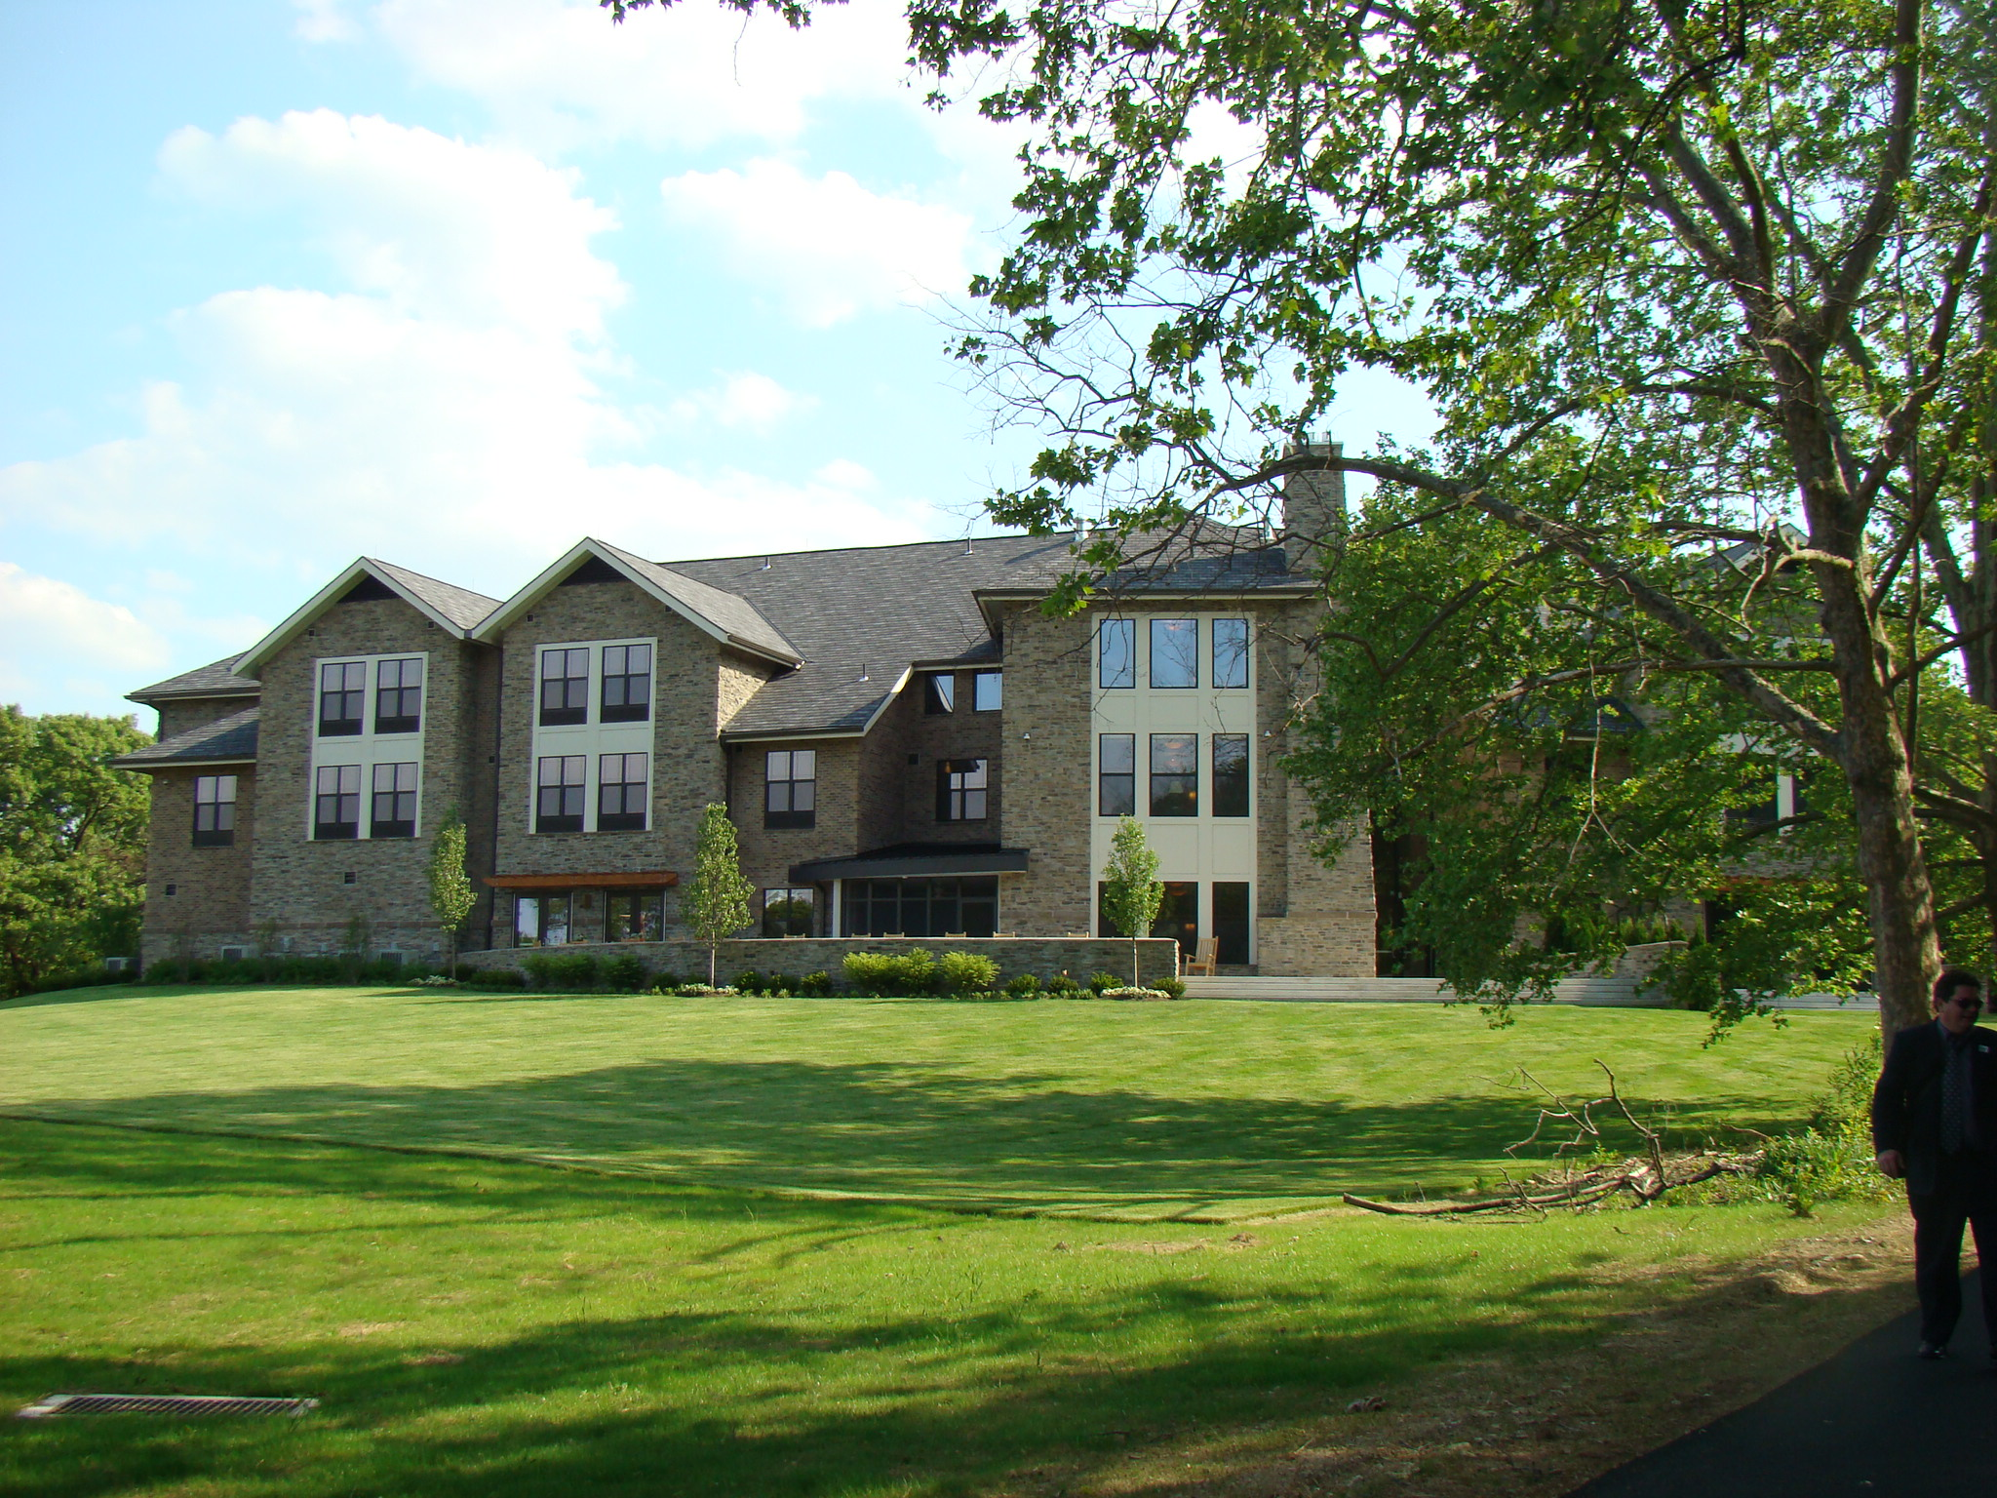

Benefiting Astra Zeneca Hope Lodge of Philadelphia

Project of the American Cancer Society